EMI LOGO

EMI PRODUCTS, LLC

**HELIX PIER FOUNDATION INSTALLATION**

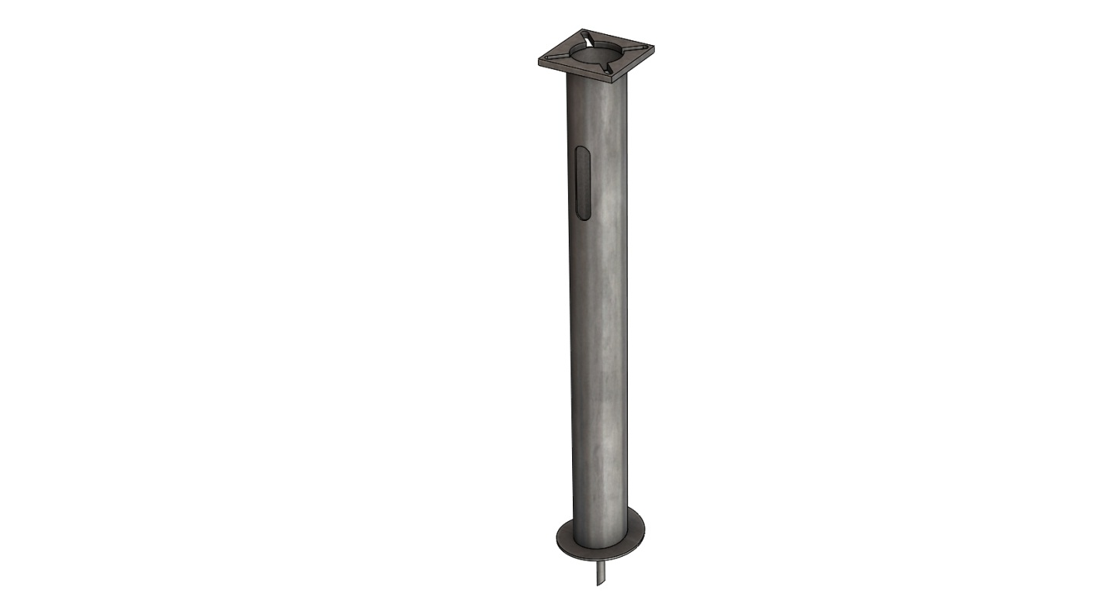

EMI PRODUCTS, LLC

**Reviewed by: CS**

**Approved by: ES**

**Date: 03/24/17 Rev -**

11230 Neeshaw Drive

Houston, TX 77065

Telephone: (281) 894-1600

Fax: (281) 894-1620

**HELIX PIER FOUNDATION INSTALLATION**

1. **STANDARD INSTALLATION PROCEDURE**
2. Assemble the universal driving tool on the correct Kelly bar adapter.
3. Attach the driving tool assembly to the foundation base plate.
4. Stand the foundation upright and attach the drive tool assembly to the Kelly bar.
5. Raise the Kelly bar and allow the foundation to swing free of the ground.
6. Maneuver the foundation directly over the installation point.
7. Lower the Kelly bar until the point of the foundation is forced into the ground and the helix is flush with grade.
8. Screw foundation 2” to 6” into the ground and plumb using a level on 2 sides 90 degrees from each other.
9. Continue screwing the foundation into the ground while correcting the Kelly bars orientation so the foundation embeds itself straight in a smooth constant motion. A ground man can be of assistance in keeping the foundation plumb during the installation.

1. Drive the foundation until the base plate is 8” above grade, stop the driving tool. Remove the Kelly bar adapter and the installing tool.
2. If the center of the foundation does not fill with soil or local material during installation, you may use the following options;
3. Fill the center of the foundation with cuttings from the auger, sand, small gravel or a premix bagged concrete material.
4. If concrete premix is not used to fill the center of the pier, a cap of concrete shall be placed just below the conduit portals to prevent water from pooling inside the foundation. **Note:** Concrete premix shall be “Quikrete” or equivalent bagged mix with aggregate not to exceed ½”. The premix may be poured dry.



**Figure 1 – Diagram of Properly Installed Pier**

The drilled pier foundation is designed to minimize soil disturbance and time involved for installation compared to other types of foundations. The minimum requirements for properly installed helical pier are 1) to achieve penetration so the pier’s top base plate is 8” or less above grade and 2) achieve a minimum torque value of 3,000 foot-pounds. A maximum torque value of 15,000 foot-pounds should be used. In the event the helical pier foundations cannot be installed per the standard procedure above, one of the following Alternative Procedures should be used.

1. **Alternative Installation Procedure #1 (10” Auger)**
2. Using a 10” auger, drill to a depth of 9 to 10 feet while minimizing enlargement of the bore. Drill the pier into the hole using the standard methodology and parameters.
3. Fill the center of the foundation with cuttings from the auger, sand, small gravel or a premix bagged concrete material.
4. If concrete premix is not used to fill the center of the pier, a cap of concrete shall be placed just below the conduit portals to prevent water from pooling inside the foundation.
5. Fill the space outside the pier with a premix concrete to a level just below the conduit portals.
6. **Alternative Installation Procedure #2 (12” Auger)**
7. In the case where more resistance is found from rock or other material, a 12” auger should be used.
8. Remove the cuttings from the hole and place the pier.
9. Ensure the pier is plumb.
10. Fill the space outside the pier with a premix concrete to a level just below the conduit portals.
11. Fill the center of the foundation with cuttings from the auger, sand, small gravel or a premix bagged concrete material.
12. If concrete premix is not used to fill the center of the foundation, a cap of concrete shall be placed just below the conduit portals to prevent water from pooling inside the foundation.
13. **Alternative Installation Procedure #3 (New Location or Precast)**

In the event the base-plate is more than 8” above grade, due to subsurface conditions including bedrock, boulders and other immovable objects;

1. Consider changing the location several feet while maintaining the required minimum antenna separation requirements. Follow the steps of appropriate procedures above.
2. If an alternate location is not possible, the use of a precast foundation should be considered.